13. Create a folder called myteam in your home directory and change its permissions to read only for the owner
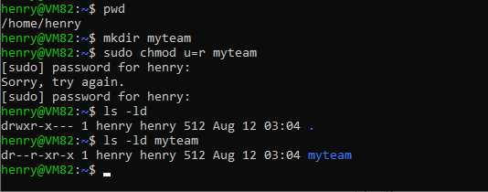
14. Log out and log in by another user
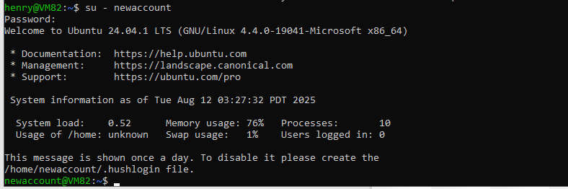
15. Try to access (by cd command) the folder (myteam)
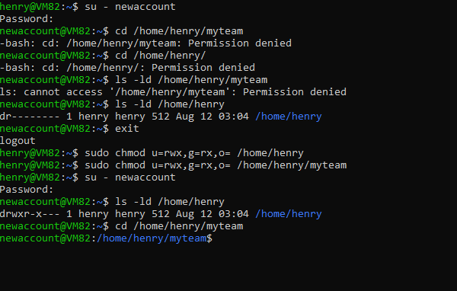
16 - a
Using the command Line Change the permissions of oldpasswd file to give owner read and write permissions and for group write and execute and execute only for the others (using chmod in 2 different ways)
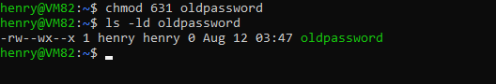
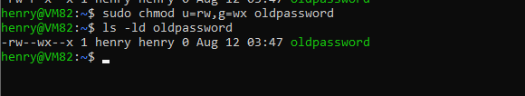
b -
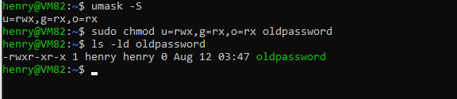
c -
Files with 666
directories with 777
d-
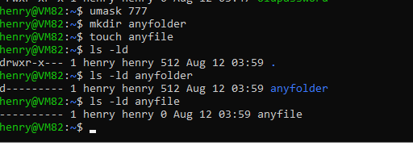
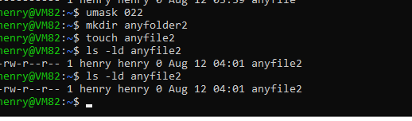
17 -
file FolderSource FolderDes
copy r-- --x -wx
move --- -wx -wx

file folder
delete --- -wx
Rename --- -wx

Folder FolderSource FolderDes
Copy rx --x -wx
18-
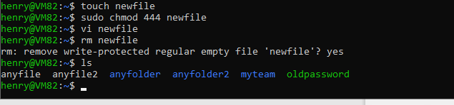
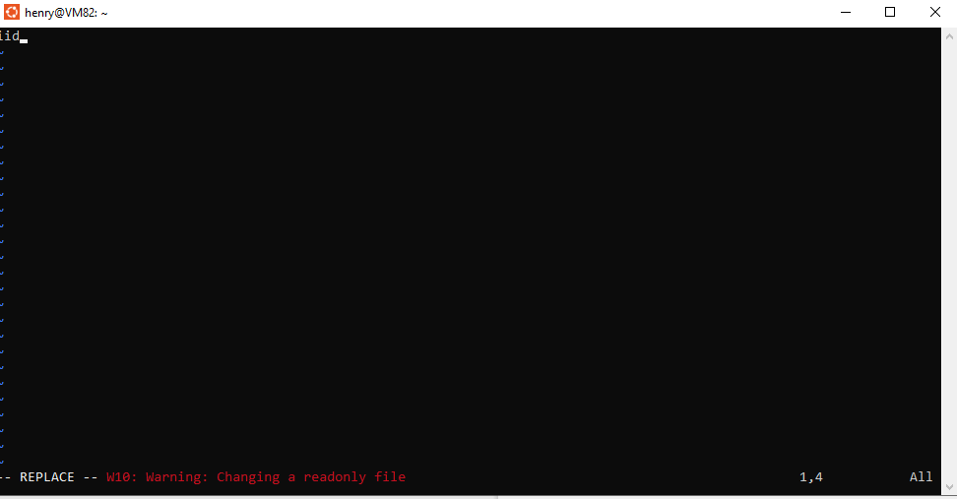
19-
File : Permission to run/execute the file
Directory: Permission to enter/traverse the directory
lab 3
1-
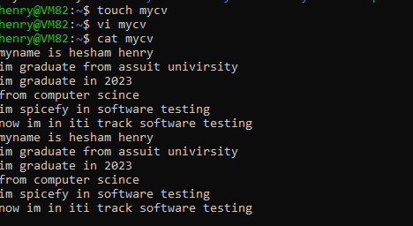
3-
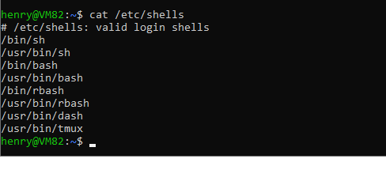
4-
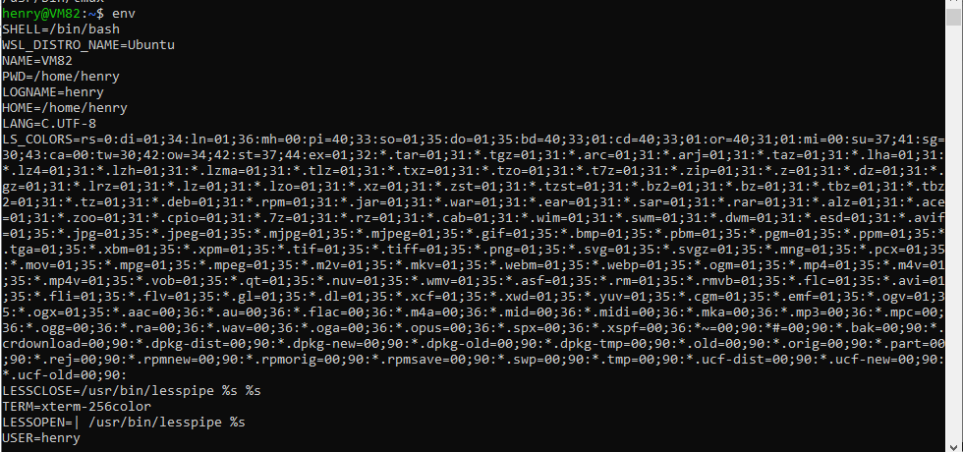
5-
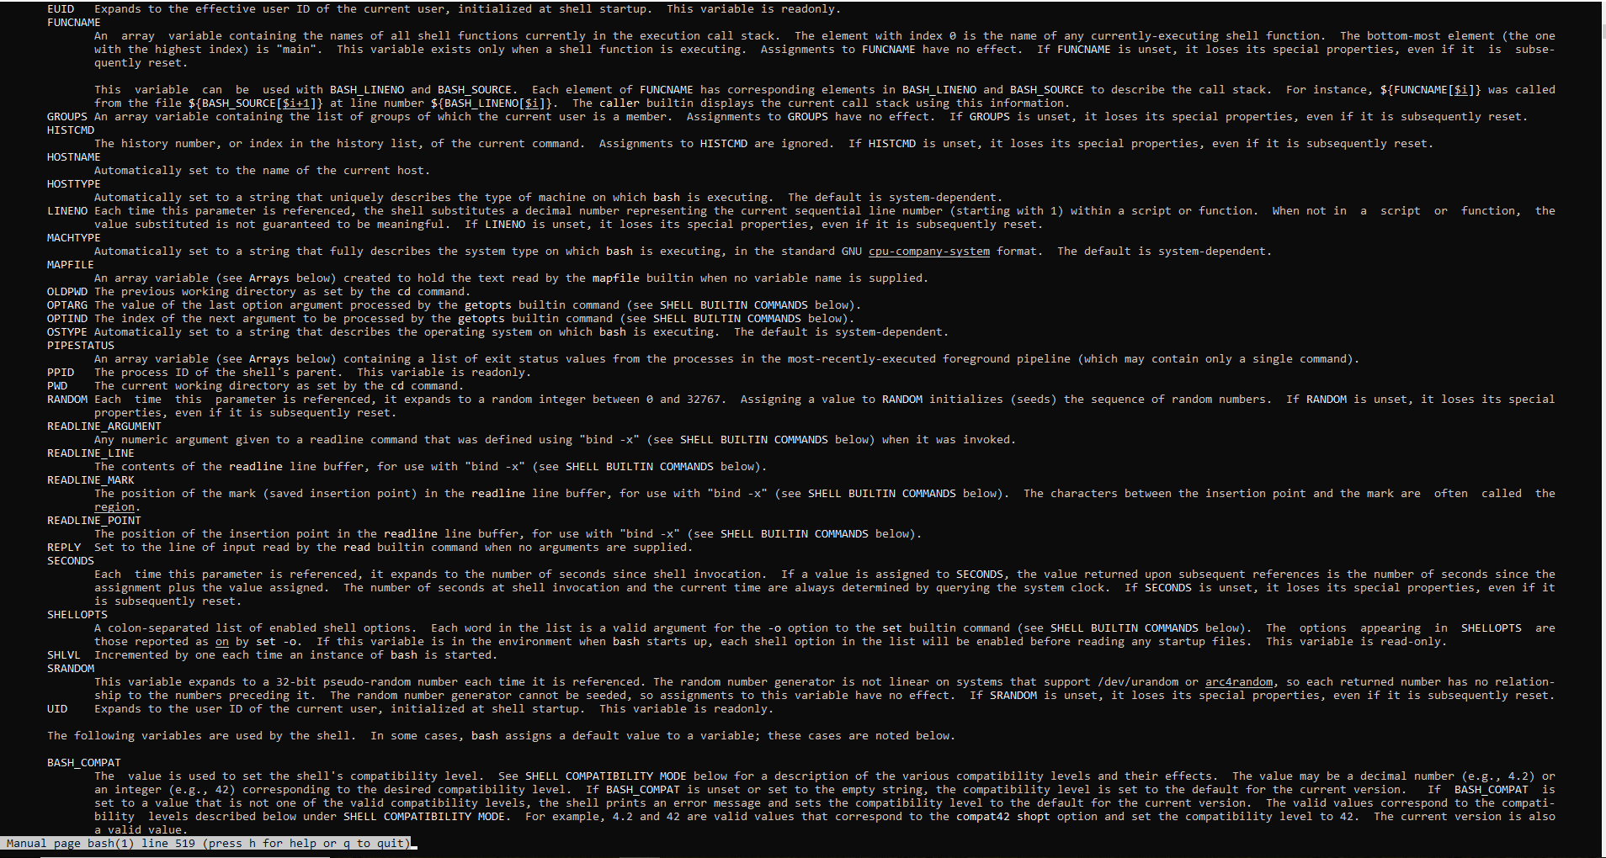
6-
7-
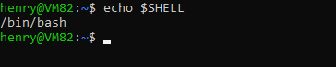
8-
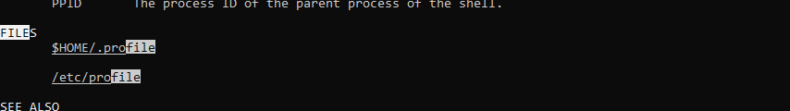
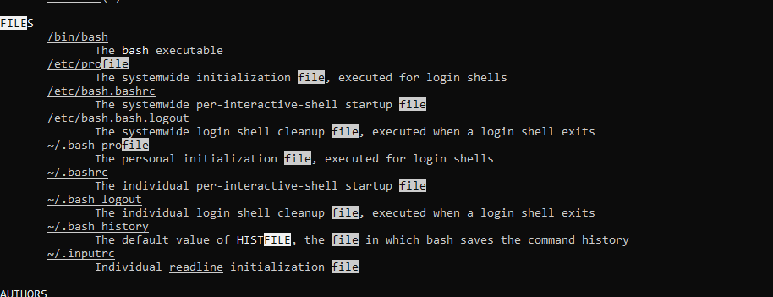
9-
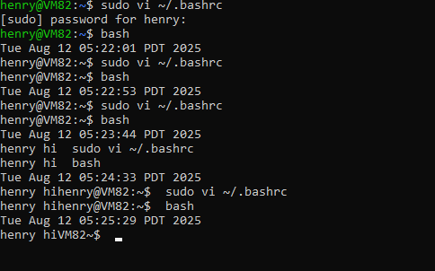
10-
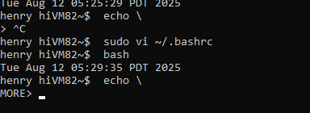
11-
